Question:
Write a Library Management System program using Kotlin.
Aim:
To develop a Library Management System using Kotlin that allows the user to add books, display the list of books, and issue books through a menu-driven interface.
Program:
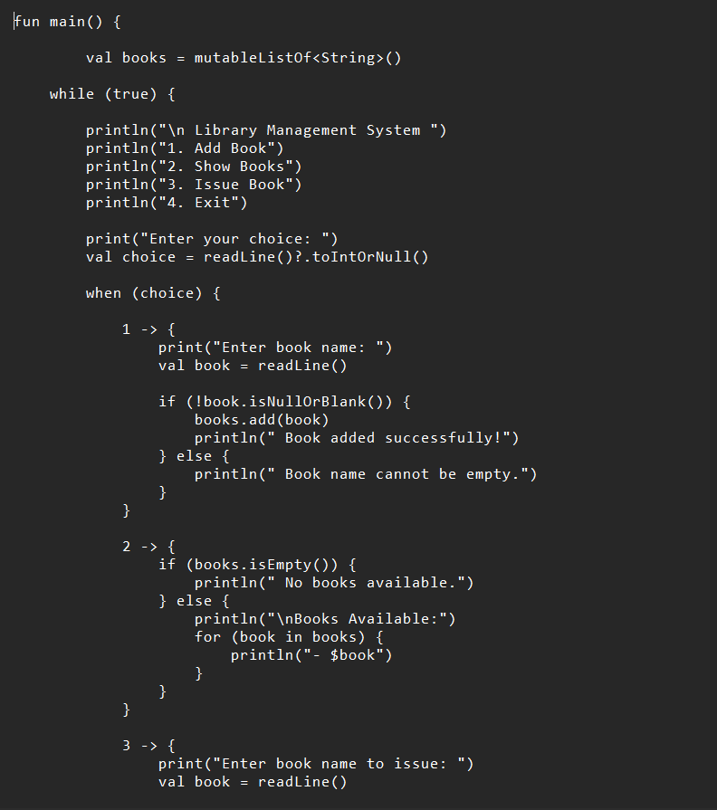

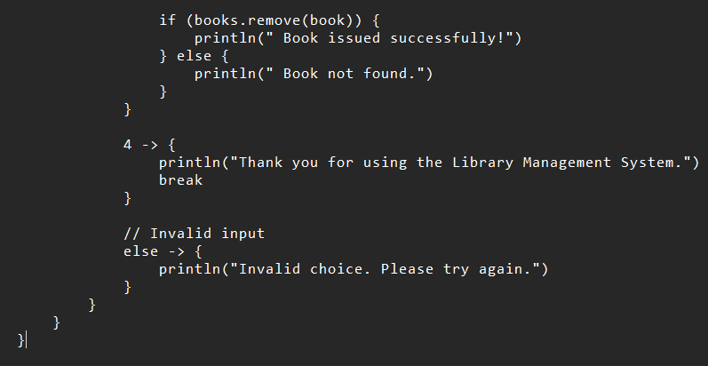

Output:
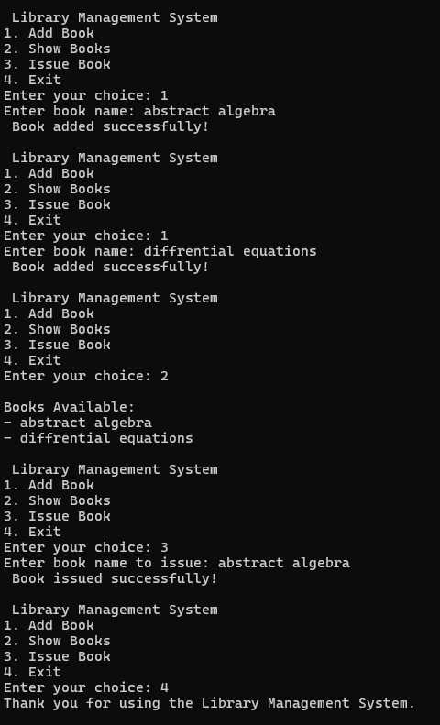
Conclusion
The above program has been executed successfully

